**Vanier College**

**Faculty of Science and Technology**

**System Development**

**420-940-VA sect. 01222**

**Deliverable 2**

**“CareCycle”**

**9/22/2023**

**Orange Team**

**Li Fan**

**Man Yin Hardas Lee**

**Ana Pechonkin**

**Charles Darrell Pinangat**

**Hill Steevenson Tassy**

**Rubing Zhang**

**In collaboration with Atelier Culture Vélo**

**Contact: Lidia Iarotsky**

We, the Orange Team, certify that this assignment is our own work

I, Charles Darrell Pinangat, student ID# 0786933, certify that I have contributed to this

deliverable, C.D.P.

I, Ana Pechonkin, student ID# 0972547, certify that I have contributed to this

deliverable, A.P.

I, Steeve H. Tassy, student ID# 2395011, certify that I have contributed to this

deliverable, S.H.T.

I, Man Yin Hardas Lee student ID# 2395055, certify that I have contributed to this deliverable,

M.Y.H.L.

I, Li Fan, student ID# 2395027, certify that I have contributed to this deliverable,

L.F.

I, Rubing Zhang, student ID# 2295411, certify that I have contributed to this deliverable, Z.R.

**Table of Contents**

***Executive Summary 3***

***Business Domain 4***

***Business Environment 4***

***Client/Sponsor 5***

**Client Description 5**

**Mission: 5**

**Contact Person: 5**

**Computer Skills 6**

**Board Members: 6**

**Volunteers/Employees: 6**

**Clientele: 6**

***Business Problem 7***

**Original Business Problem: 7**

**After Interviewing the Client: 7**

**How Our Web Application Can Help 7**

***Open Questions 8***

***Questionnaire 9***

***Questions to be Asked at Next Client Meeting 12***

***Bibliography 13***

# 

# 

# **Executive Summary**

Atelier Culture Vélo, a nonprofit organization in the bicycle industry, plays a vital role in promoting active transportation and cycling education. The organization has a diverse clientele and a mission that covers bicycle repair and sales, advocacy efforts, and educational workshops. Their inclusive approach extends to minorities, women, immigrants, newcomers, and the queer community, promoting diversity within cycling.

To better understand the challenges facing Atelier Culture Vélo, we initiated a process that began with creating a questionnaire and conducting an interview with the client. This allowed us to gain valuable insights into their specific needs and operational pain points. We also learned about their history, having previously operated within Vrac Environment before establishing themselves as an independent entity.

Their challenges include labor-intensive manual recording of client statistics and volunteer attendance. Additionally, the organization encounters limitations in managing reservations, inefficient inventory handling, and a complex cash processing system. Notably, they use Lightspeed for their cash system and Timify for reservations.

Our top priority will be to automate client statistics collection (postal code, year of birth, gender (as inclusive as possible), country of origin) and volunteer attendance. After that, if time allows, we'll work on improving the reservation system, inventory control, and simplifying cash processing.

This tech upgrade will help Atelier Culture Vélo allocate resources better, make data-driven decisions, and improve their chances of getting grants/funds while working toward self-sustainability. Hopefully, this will also increase their chances of staying open and continuing to support the community, addressing the fear of potential closure.

In summary, our web app will empower Atelier Culture Vélo to support sustainable transportation and inclusivity in the cycling community, adapting to Canada's evolving bicycle market and promoting environmental and health-conscious living.

# **Business Domain**

The bicycle industry or cycling industry can broadly be defined as the [industry](https://en.wikipedia.org/wiki/Industry_(economics)) concerned with [bicycles](https://en.wikipedia.org/wiki/Bicycles) and [cycling](https://en.wikipedia.org/wiki/Cycling). It includes at least [bicycle manufacturers](https://en.wikipedia.org/wiki/List_of_bicycle_manufacturers), part or component manufacturers, and accessory manufacturers. It can also include [distributors](https://en.wikipedia.org/wiki/Distribution_(business)), [retailers](https://en.wikipedia.org/wiki/Retailing), bicycle organizations, bicycle event promoters, and bicycle related service providers.

A [bike shop](https://en.wikipedia.org/wiki/Bike_shop) or bicycle shop is a business specializing in [bicycle](https://en.wikipedia.org/wiki/Bicycle) sale, [maintenance](https://en.wikipedia.org/wiki/Maintenance,_repair,_and_operations) and parts. Bike shops may be [small businesses](https://en.wikipedia.org/wiki/Small_business), [chain](https://en.wikipedia.org/wiki/Chain_store), [mail-order](https://en.wikipedia.org/wiki/Mail-order) or [online](https://en.wikipedia.org/wiki/Electronic_commerce) vendors. Local bike shops are a key component of the bicycle industry and, in recognition of the value that local bike shops provide, some [manufacturers](https://en.wikipedia.org/wiki/Manufacturers) only sell their bicycles through [dealerships](https://en.wikipedia.org/wiki/Dealerships).

Non-profit community bike shops exist to serve a different crowd than traditional bike shops. While many traditional bike shops focus on a relatively affluent customer base, community bike shops serve a much broader range of people, including low-income and working-class residents. Many of the people who rely on a bike to get around may not have the resources to purchase a bike or pay for expensive services.

Non-profit bike shops provide bicycles, classes, services, and social support, who rely on donations of bicycles, parts, and funds. They may also seek grants from government agencies, foundations, and private donors to support their programs. They also rely heavily on volunteers who contribute their time and expertise to repair bikes, teach maintenance skills, and assist with shop operations.

In conclusion, the bicycle industry encompasses a diverse array of stakeholders, all dedicated to the world of bicycles and cycling. Local bike shops, a vital component of this industry, offer sales, maintenance, and parts, with some manufacturers exclusively partnering with them to tap into their value. In contrast, non-profit community bike shops play a unique role by catering to a broader, often underserved population, offering not only bicycles and services but also educational programs and a sense of community.

# 

# **Business Environment**

The Bicycles market in Canada has been experiencing steady growth in recent years.  
  
**Customer preferences:** One of the main reasons for this growth is the increasing popularity of cycling as a means of transportation and recreation. Canadians are becoming more health-conscious and environmentally aware, and many are opting to ride bicycles instead of driving cars or using public transportation. Additionally, cycling is seen as a more affordable and convenient mode of transportation, especially in urban areas where traffic congestion is a common issue.  
  
**Trends in the market:**Another trend in the Canadian Bicycles market is the growing demand for electric bicycles. Electric bicycles provide an alternative to traditional bicycles by offering an assisted pedaling experience, making it easier for riders to travel longer distances or tackle hilly terrain. The convenience and environmental benefits of electric bicycles have made them increasingly popular among Canadians.  
  
**Local special circumstances:**Canada's vast and diverse landscape also contributes to the growth of the Bicycles market. The country offers a wide range of cycling opportunities, from urban bike lanes to scenic trails in national parks. This variety of cycling experiences attracts both locals and tourists, further driving the demand for bicycles.   
  
**Underlying macroeconomic factors:**Several macroeconomic factors have also played a role in the growth of the Bicycles market in Canada. The country's stable economy and high disposable income levels have allowed Canadians to invest in bicycles as a form of leisure and transportation. Additionally, government initiatives promoting cycling infrastructure and active transportation have further encouraged the adoption of bicycles.

In Quebec, Despite the extended and chilly winters, individuals make the most of their cycling opportunities whenever weather conditions permit, highlighting their dedication to enjoying the sport.

# 

# **Client/Sponsor**

## **Client Description**

**Atelier Culture Vélo**

7930 boul. St-Laurent

Montréal (QC) H2R 2Y2

<https://atelierculturevelo.ca>

A community organization non-profit that aims to educate people about active transport, more specifically bicycles: the target clientele of the non-profit are minorities in the bicycle community, specifically women and immigrants, as well as newly arrived and the queer community.

### **Mission:**

To increase accessibility by rendering people self-sufficient in their active transport through education about the cycling world.

### **Contact Person:**

Lidia Iarotsky, a board member, a volunteer at the non-profit and the person in charge of volunteer management will be our liaison with the non-profit. Most meetings will be with her; whatever she learns from us, she will return to the committee to discuss and vice versa.

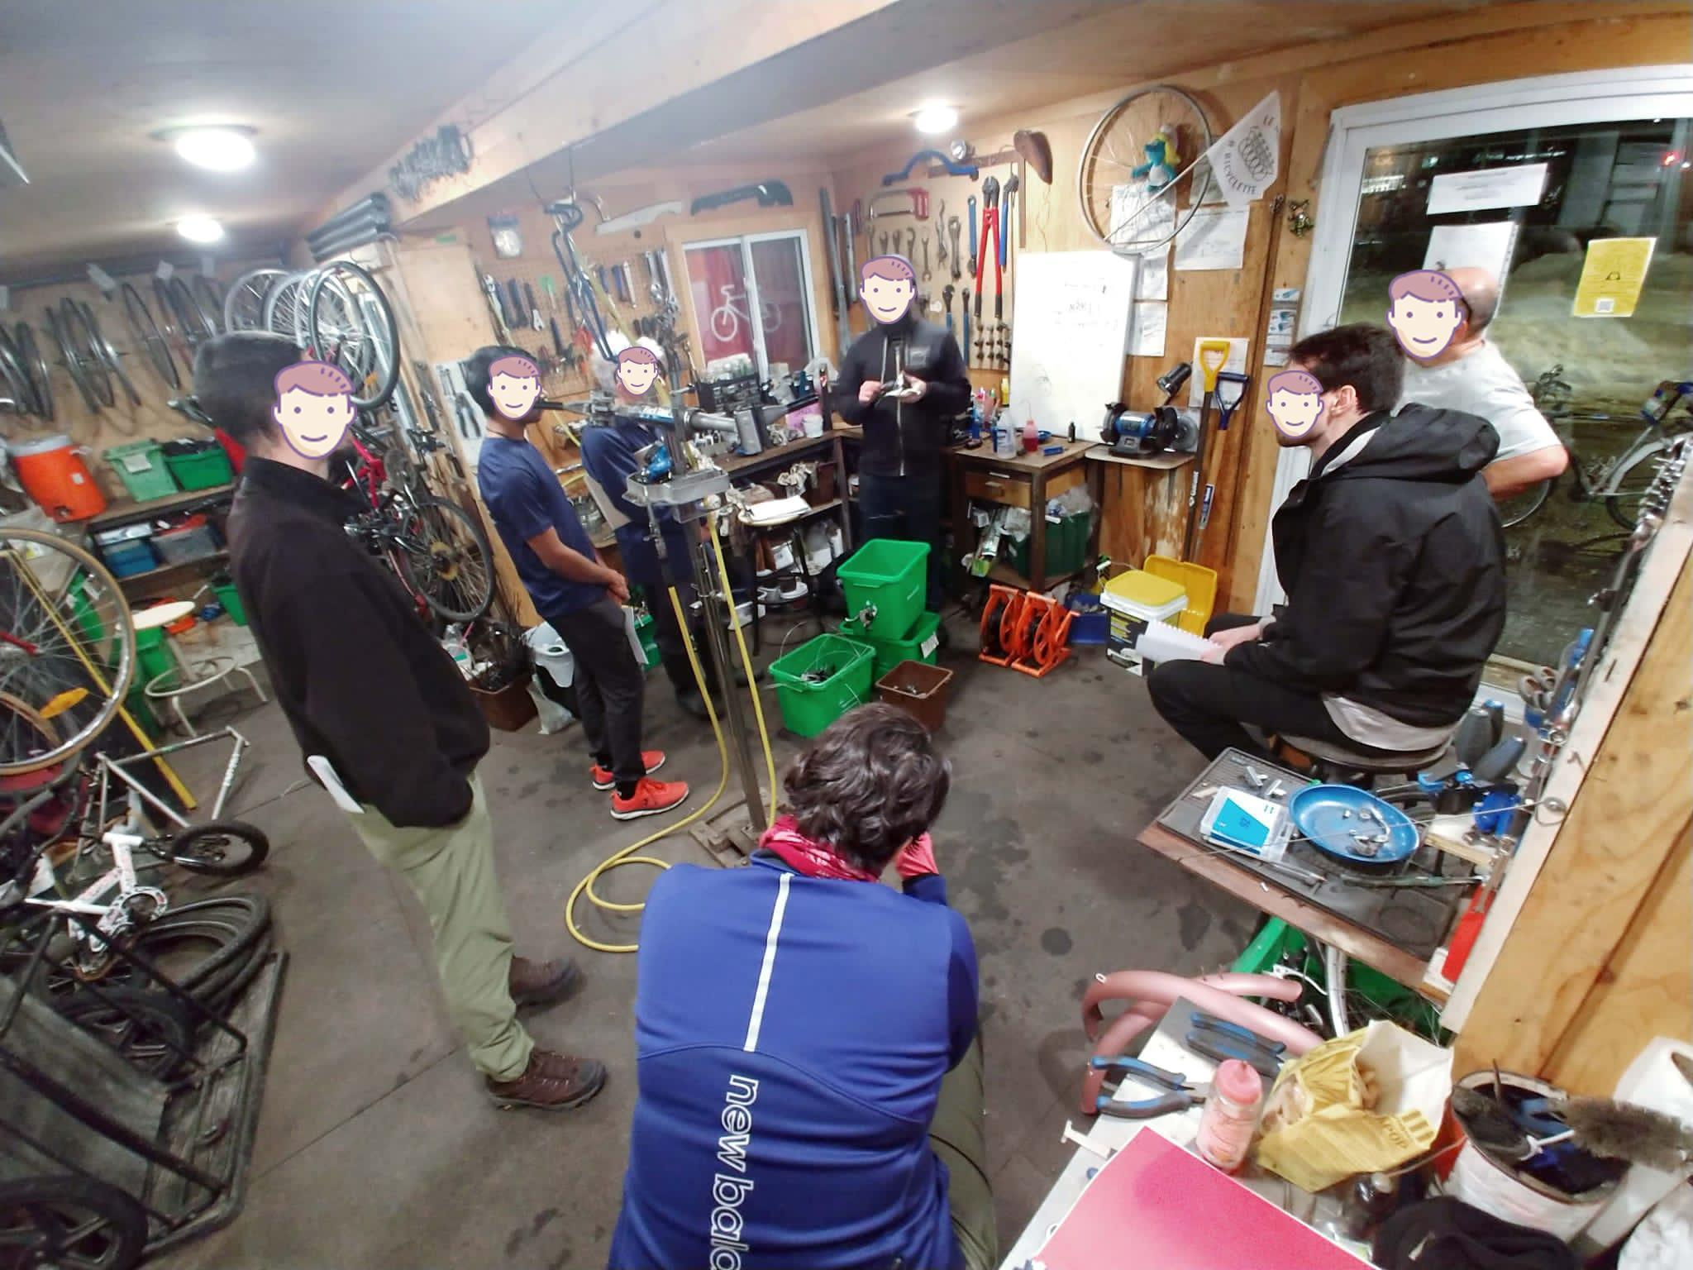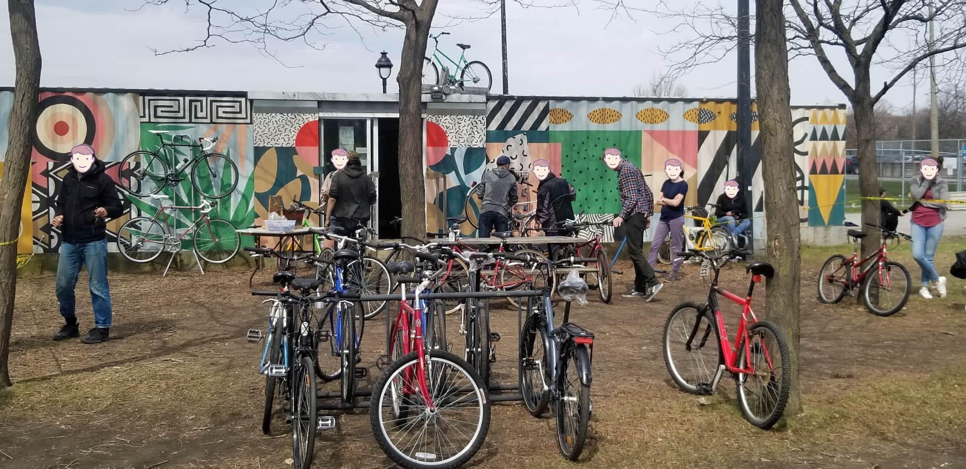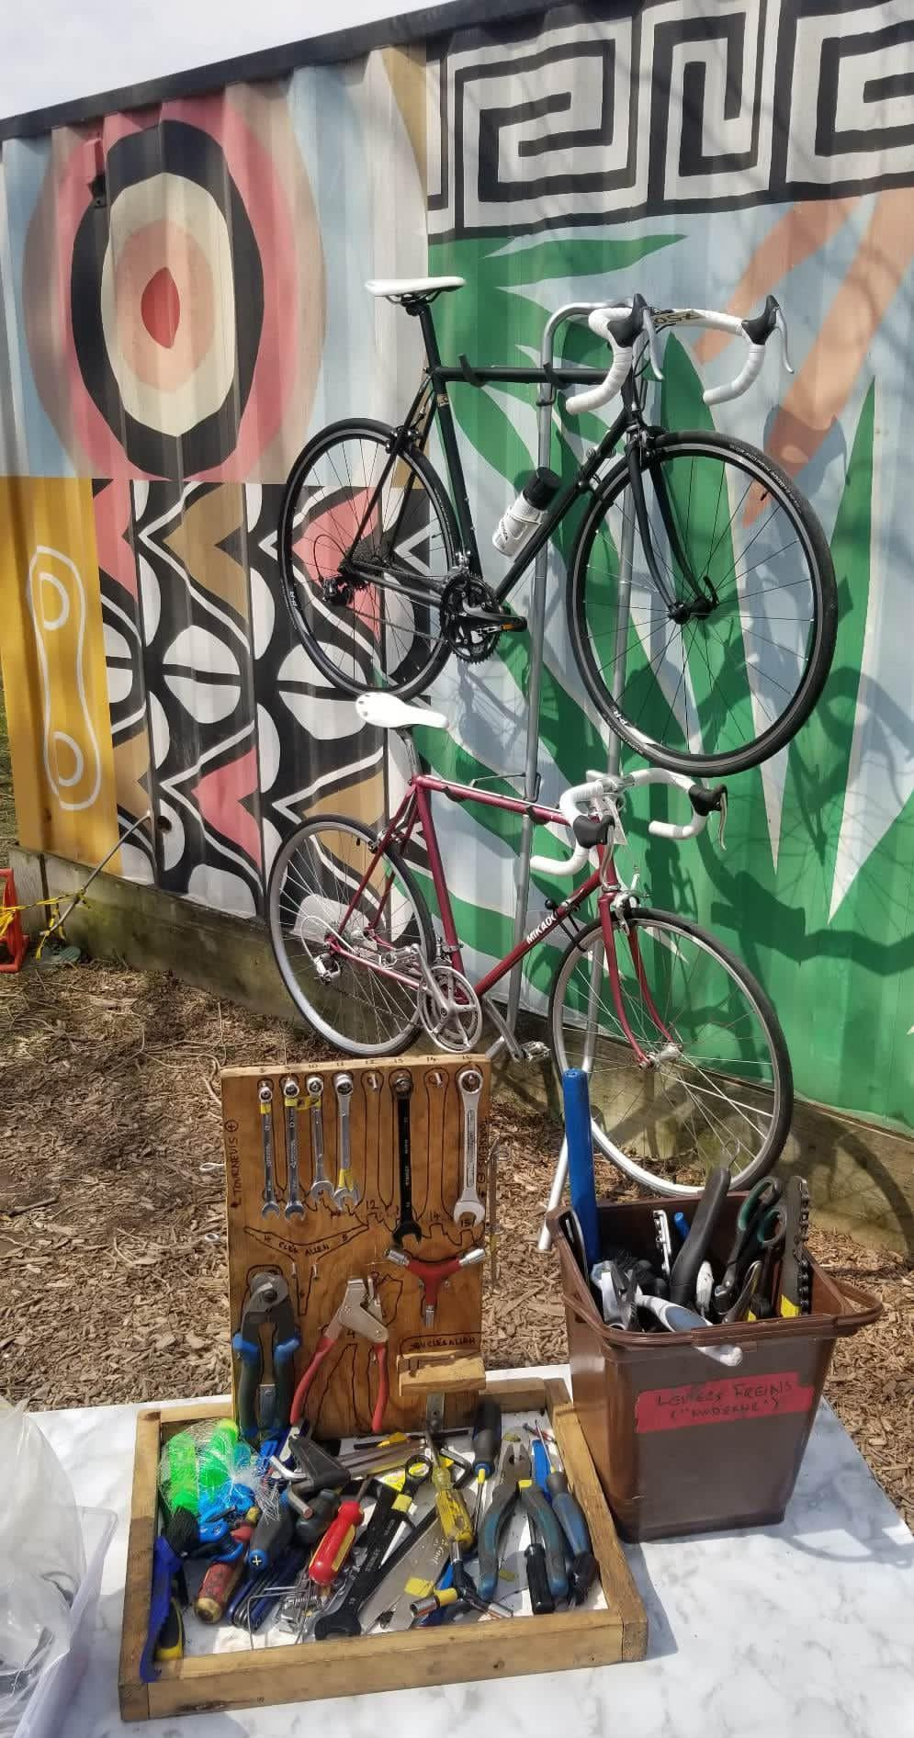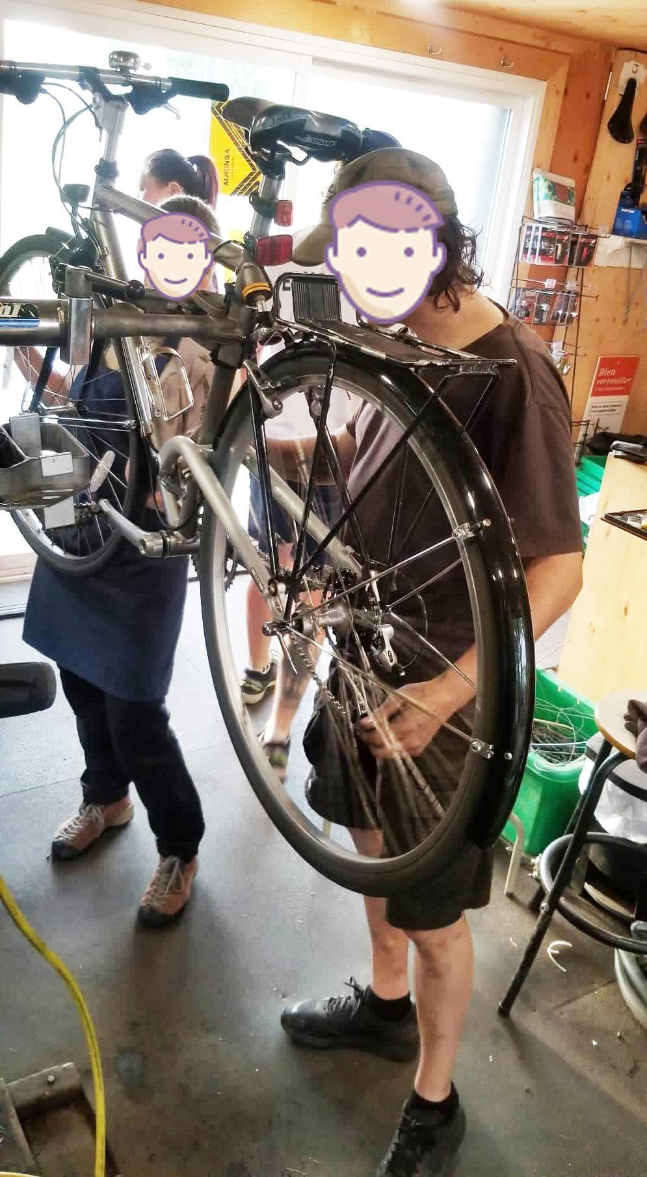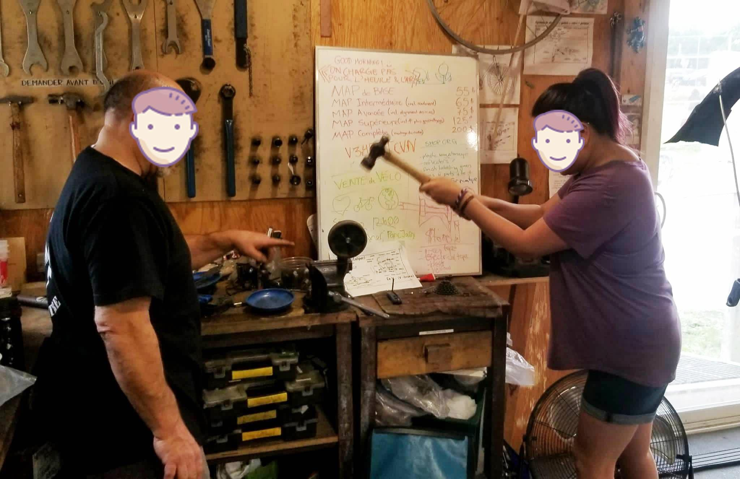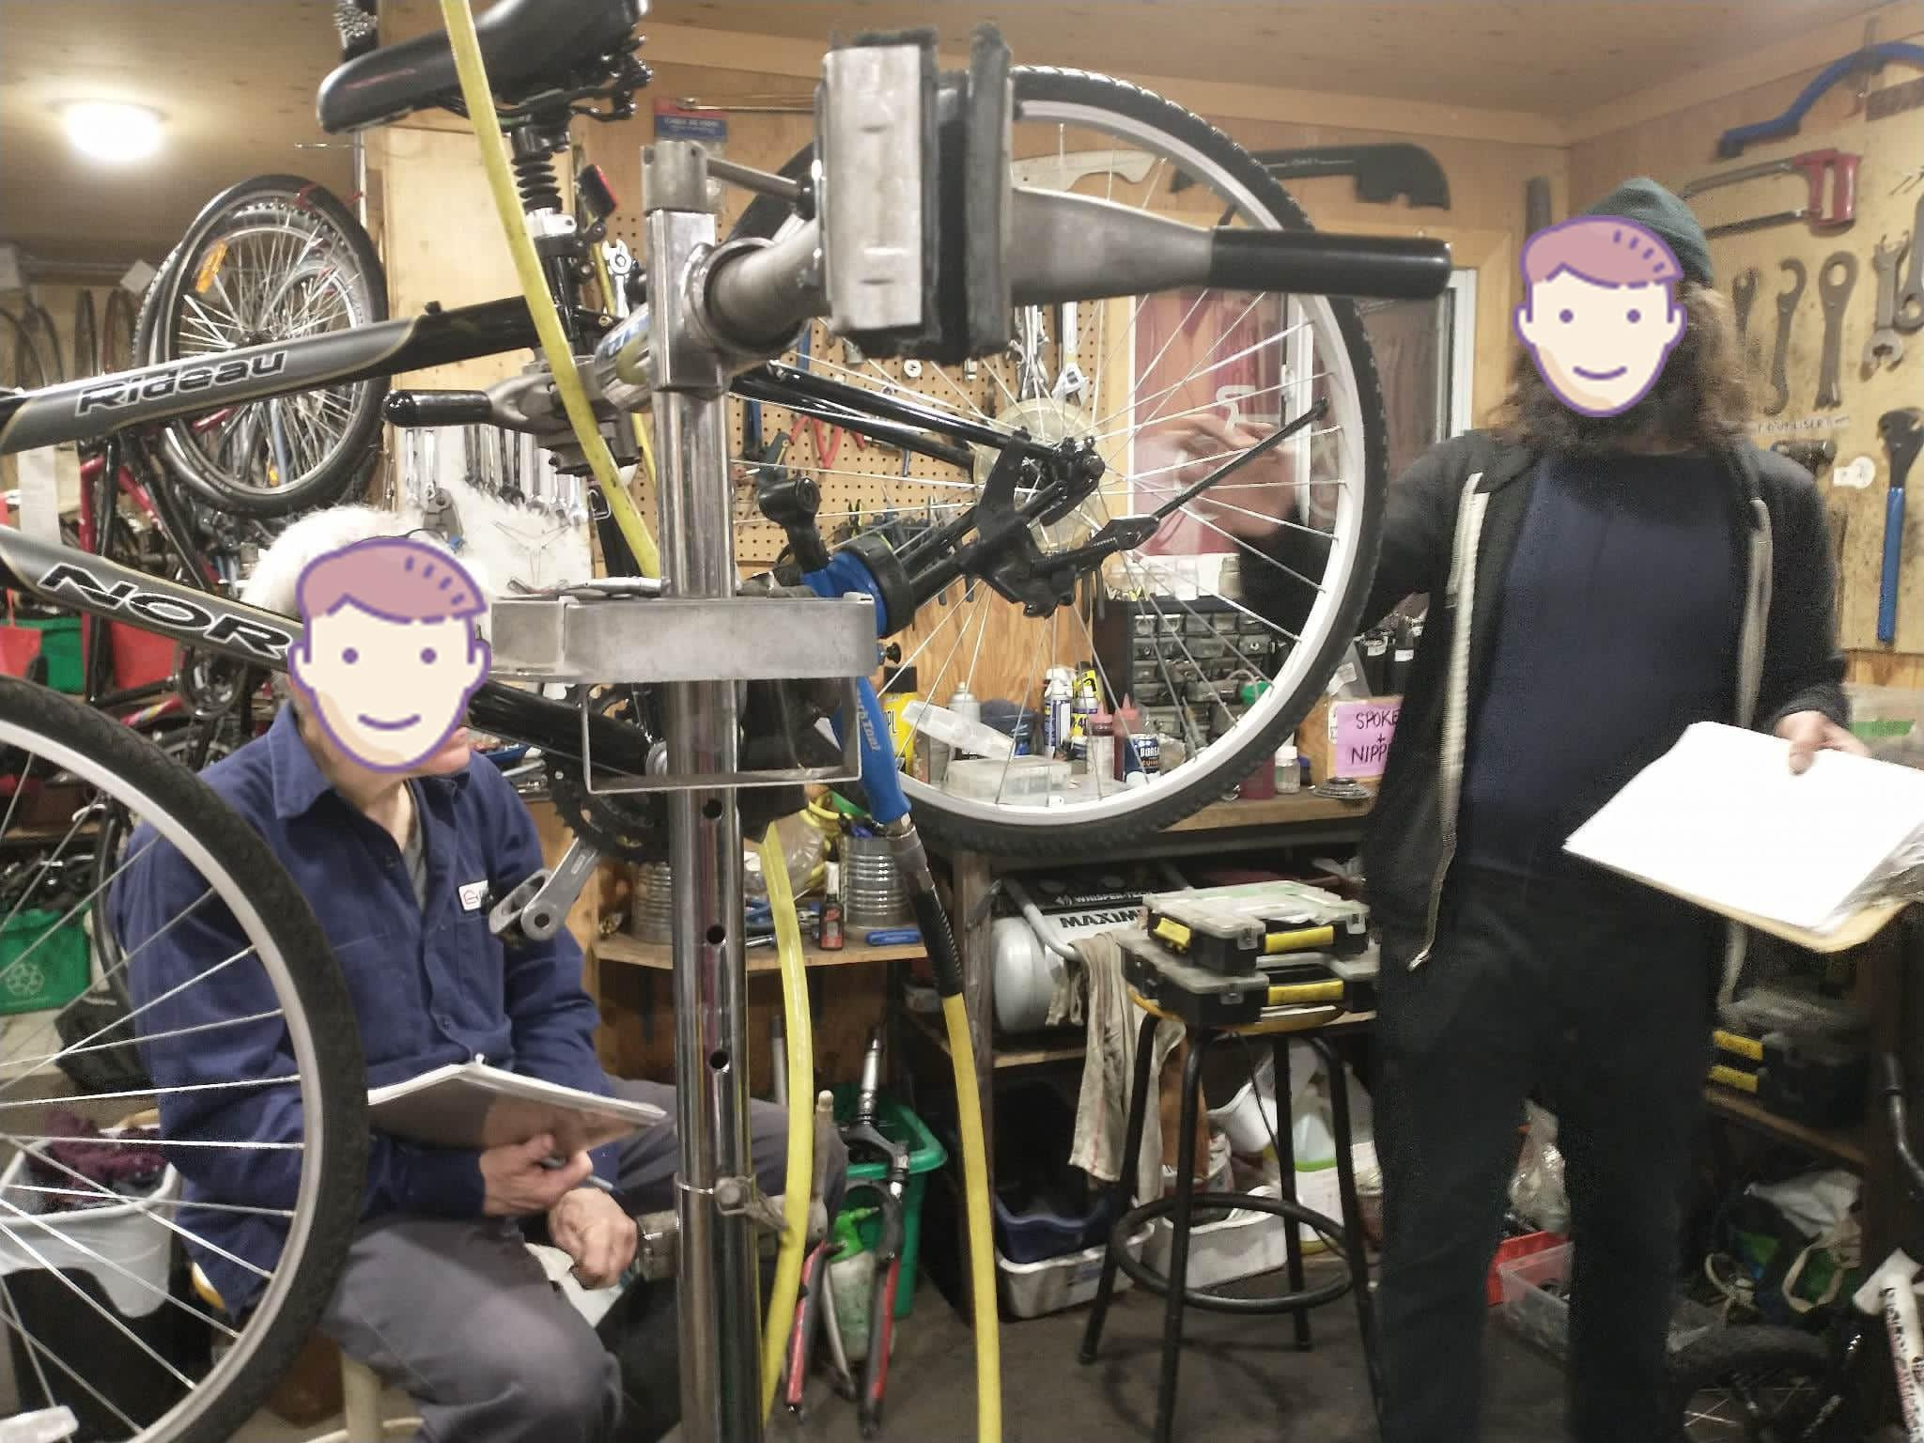

## 

## 

## **Computer Skills**

**Computer Skills Scale 1 – 10**

1-no computer skills

5- computer skills of the general population

10- computer skills of programmers

### **Board Members:**

Professionals aged 30-60 have jobs outside this non-profit and are all tech-savvy. On the tech skills scale, they would be an 8 or 9.

### **Volunteers/Employees:**

Mainly all tech-savvy; on the scale, they would be between 5-10.

Many are programmers or engineers, so they would be a ten on the scale, while others, such as kids aged 10-12, would be a 5 or 6 and others in between.

### **Clientele:**

Very diverse, so the computer skills vary on a scale between 1-10.

Language barriers could also be present, so the app needs to be as visual as possible (visual aid).

# 

# **Business Problem**

## **Original Business Problem:**

The nonprofit, Atelier Culture Velo, currently relies on manual data entry, where visitor information, including postal codes, birth years, gender (inclusive), and countries of origin, is first written by hand in a notebook. Subsequently, a staff member assists in transferring this data to a spreadsheet for grant reporting. This double-entry process is time-consuming, inefficient, and diverts valuable resources from more impactful organizational tasks.

## **After Interviewing the Client:**

During our meeting with the client, we realized that the nonprofit has more than one business problem. In addition to the stats problem, they also have problems in the following areas:

**Manual Volunteer Presence Tracking:** The process of tracking volunteer attendance remains a manual and time-consuming task, placing additional administrative burdens on the team.

**Reservation System Limitations:** Due to budget constraints, the organization relies on the free version of Timify for managing reservations. However, this cost-saving measure comes with limitations, affecting the efficiency of their reservation system.

**Inventory Management:** The organization currently operates without an official inventory tracking system. There is no inventory logbook or dedicated software for monitoring supplies. Instead, Krzysztof conducts manual assessments of the shop's inventory twice a year – once before the high season commences and again after its conclusion. This periodic approach sometimes results in shortages of critical supplies during specific periods.

**Complex Cash System:** Atelier Culture Vélo grapples with a complex and cumbersome cash processing system. Many volunteers are not adequately trained to use it, leading to potential financial losses and complications.

**Volunteer Shortage:** Volunteers are the lifeblood of the organization, yet there is a continuous need for more volunteers to support daily operations effectively.

## **How Our Web Application Can Help**

Our primary commitment is to address Atelier Culture Vélo's pressing statistics issue. Our tailored web application can revolutionize their operations by offering an accessible digital platform for clients to seamlessly input vital statistics, including postal codes, birth years, genders, and countries of origin. This streamlined process ensures Lidia and other board members have access to this valuable data in real-time, eliminating the need for laborious manual data entry at the day's end. Beyond these immediate benefits of saving time and resources, our app significantly enhances data accuracy and consistency, thereby reducing the risk of human error. Moreover, our solution features daily, monthly, yearly, and seasonal data transcripts, empowering the organization to make data-driven decisions while remaining steadfast in its core mission throughout the year.

We recognize that Atelier Culture Vélo faces a spectrum of challenges. Beyond resolving the statistics issue, we aspire to incorporate additional features into the app to help tackle these hurdles. One of these features is a volunteer presence tracking tool designed to simplify attendance records. This feature will empower volunteers to easily log their presence by selecting the date and providing their name within the app. The system will then record their attendance, creating a comprehensive log. This log will be accessible to authorized personnel, enabling them to review who was present on specific days, thereby enhancing transparency and accountability within the organization.

If time allows, our goal is to create a reservation system within the app, eliminating the need for external platforms like Timify. We're also keen on addressing their inventory and cash system complexities, striving to provide a holistic solution that streamlines operations, optimizes resources, and empowers the organization to better serve its community.

# 

# **Open Questions**

We are not sure how well the inventory is maintained. Based on the last interview, it appears that Kryzsztof, an employee at Atelier Culture Velo, does it visually, which is almost the same case for the pricing of the items. We are not sure if all the items are listed in their cash system (Lightspeed) either. Other uncertainties consist of how their scheduling system (Timify) functions and why they wish to update this other than it being tedious. But that is a main concern for them.

It is also unknown if they have a secure means to communicate messages or announcements to those who may not be present during the meetings. We also briefly asked the client what helps to receive grants, and although we may not be able to assist when it comes to the required connections, our assistance in providing accurate and detailed reports may help them towards their goal.

The client’s parts are acquired via donations and through a distributor called Babac. Inquiring about their supplier prompted us to question whether they have other suppliers, to which they responded that they primarily rely on this one distributor. We probed further into the reasoning behind this, and it appears that other suppliers are hesitant to serve nonprofits due to concerns about potential competition with other bicycle stores. This revelation challenges the notion that bicycle stores view them as direct competitors, suggesting a more complex dynamic. It is a tiny and unquestionably competitive market, with under a dozen nonprofit bike repair shops in Montreal. One main competitor is called La Remise.

# 

# 

# **Questionnaire**

1. **Describe your Industry and what you do on a daily basis.**

-Bicycle/Cycling Industry: repair bicycles on a daily basis (seasonal tune-ups).

- Selling bicycle parts.

-Activism: Advocacy on behalf of the cycling community.

-Education: Teaching bicycle repair workshops and educating people on the benefits of riding bicycles as the main source of transport.

1. **Do you use any software currently to do any daily task etc?**

-LightSpeed for the cash (*for now, do not touch for project) -Timify for bike repair reservations through their website

1. **What are the things during your day that require the most time?**

-Cash Processing

-Bicycle Repairs

1. **What tasks do you think can be mitigated with software technology , or you would like to be mitigated with software technology?**

-Stats about clientele being served at the shop during workshops (anonymous)

-Volunteer presence: counting how many volunteers were present on the day

-Inventory

-To do lists/calendar (tasks, reminders)

1. **How did you get into the business?**

In 2012, they initially operated within the larger organization, Vrac Environnement. Their primary role within this organization was to coordinate temporary bike repair workshops throughout the city and engage in educational programs within schools to teach children bicycle repair skills. However, when Vrac Environment shifted its focus away from bicycles, Atelier Culture Velo separated and established itself as an independent entity in 2018-2019. Set up their container bike shop at park Jarry in 2019. They successfully attained their non-profit status in 2022.

Two employees: Kryzsztof finished graduate school in neuroscience and burnt out, Joska was a nurse and also burnt out before eventually joining Atélier Culture Vélo.

1. **What aspects of your job do you enjoy the most/least?**

Volunteer/Board Member-Lidia: Loves interacting with clients the most, especially kids because they are always impressed with everything. She doesn’t like the cash system they have in place.

Volunteer-Tyler: Loves fiddling with bicycles the most. Hates it when he needs to give bad news to a client about their bike, like when he needs to tell them that the bike isn’t worth trying to repair.

1. **What type of challenges do you face on a daily basis?**

**-** Community issues: safety on the roads

- Cash system: complicated, not efficient, not all volunteers are trained for it which leads to the loss of money

1. **How do you keep inventory? What software do you use? SAP? ORACLE?**

They do not maintain an official inventory logbook or utilize software for tracking purposes. Instead, Krzysztof conducts manual assessments of the shop's needs twice a year – once before the onset of the high season and again after its conclusion. This periodic approach sometimes leads to shortages in supplies during certain periods.

1. **How do you do invoicing? Like the number of hours of labor to be charged for the client? Price for the material used.**

-New sales/transactions done on LightSpeed (need password).

-More about invoicing to be discussed at the next meeting.

-Waiting for Lidia to get back with documents on membership prices and billing info.

1. **How do you foster innovation within a team or organization?**

To foster innovation within a team or organization, occasional bike trips and post-work gatherings for food and drinks with volunteers are organized. Announcements are made during these gatherings.

1. **Does the company have any Marketing Initiatives, if so by which means? (Facebook, Twitter, Radio, TV, etc…)**

The company primarily utilizes Facebook as a marketing channel, with updates posted approximately every six weeks. Additionally, they maintain an online presence through their website at <https://atelierculturevelo.ca/>.

1. **What are the company views towards Sales?**

Their focus is not on sales but rather on empowering individuals to expand their knowledge of bicycles and equipping them with the skills to perform repairs. Their broader goal is to educate people about sustainable living while fostering greater self-sufficiency.

1. **What are the traits/skills necessary to do your job?**

To perform the roles of Joska and Krzysztof, the two full-time employees, you must be skilled in bicycle repair, essentially making you a bicycle mechanic.

Volunteering doesn't require any specific qualities or expertise since there are various tasks beyond bike repair, including administrative duties. Currently, there is a need for a volunteer to assist with grant applications.

1. **How do you respond to a “No” or a negative response?**

When faced with a "No" or a negative response, their top priority is ensuring security. They prioritize bike safety to prevent any potential hazards. If a repair refusal jeopardizes safety, the volunteers or employees will make efforts to communicate the importance of the repair and ensure the individual comprehends the potential dangers involved. However, they do not push for repairs that do not pose a safety hazard.

1. **Where do/does you/the company see yourself/itself 5 years from now?**

In the next five years, Krzysztof aims for the organization to reach a point where it becomes a self-sustaining nonprofit. The organization could cover its operational expenses, programs, and activities through revenue generation and community support without relying heavily on external funding sources.

Meanwhile, Lidia expressed her desire for the nonprofit to endure over the next five years, primarily because they are currently grappling with challenges in sustaining themselves as a nonprofit. Obtaining grants has proven to be a formidable task, among other difficulties they face.

# 

# **Questions to be Asked at Next Client Meeting**

1. What are the things that keep you up at night?(business related)
2. What software do you use for accounting? Cloud/Online or Desktop App?
3. How do you do invoicing? Like the number of hours of labor to be charged for the client? Price for the material used.
4. What information would you like to save about the volunteers on the app?
5. What is important to have inside an inventory system? What would you want to keep track of?

# **Bibliography**

1. <https://en.wikipedia.org/wiki/Bicycle_industry>
2. <https://chi.streetsblog.org/2020/07/14/how-nonprofit-community-bike-shops-are-coping-in-a-covid-19-world>
3. https://www.calbike.org/our_initiatives/healthy_climate_and_communities/community-bike-shops/
4. <https://www.statista.com/outlook/mmo/bicycles/canada#unit-sales>
5. https://atelierculturevelo.ca/